
Year 10
Pathway 2

Test 2

Total Marks: 28 marks
Name: ______________________ Total Time: 40 minutes

Show working and answers on this sheet. Show working in sufficient detail to support your answers. Incorrect answers without supporting reasoning may be allocated zero marks.

Resources allowed: 1 page of notes A4, 1 side. Calculator

- Identify the gradient and y intercept of the two lines below: (6 marks)

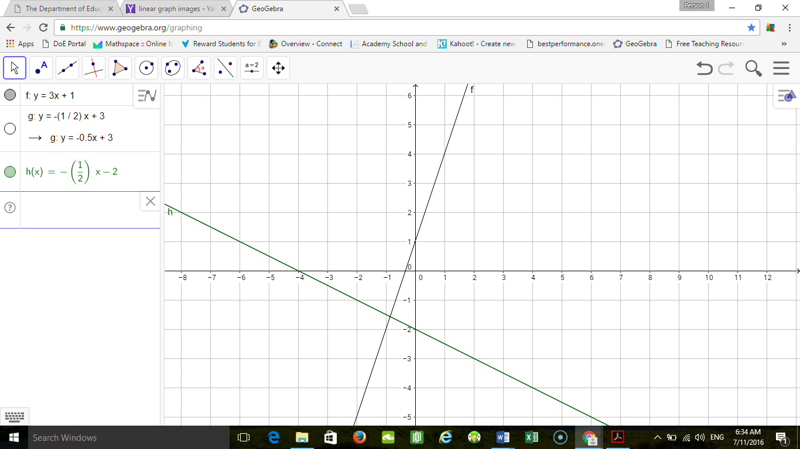

line | Gradient | Y intercept
Line 1
Line 2

Hence state the equations of the lines:

Line 1:

Line 2:
- Complete the table of values for the following quadratic relationship (7 marks)

$$x$$ | -3 | -2 | -1 | 0 | 1 | 2 | 3
y = x² - 4

- Plot the above relationship on the axes given below (3 marks)

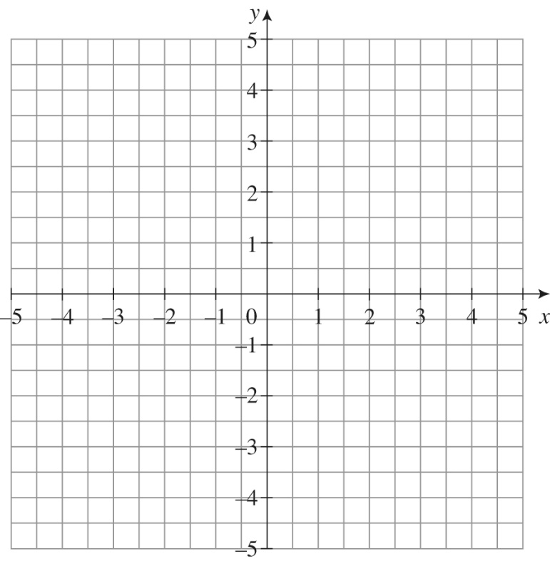
- Fill in the table for the graphs given below: (12 marks)

- 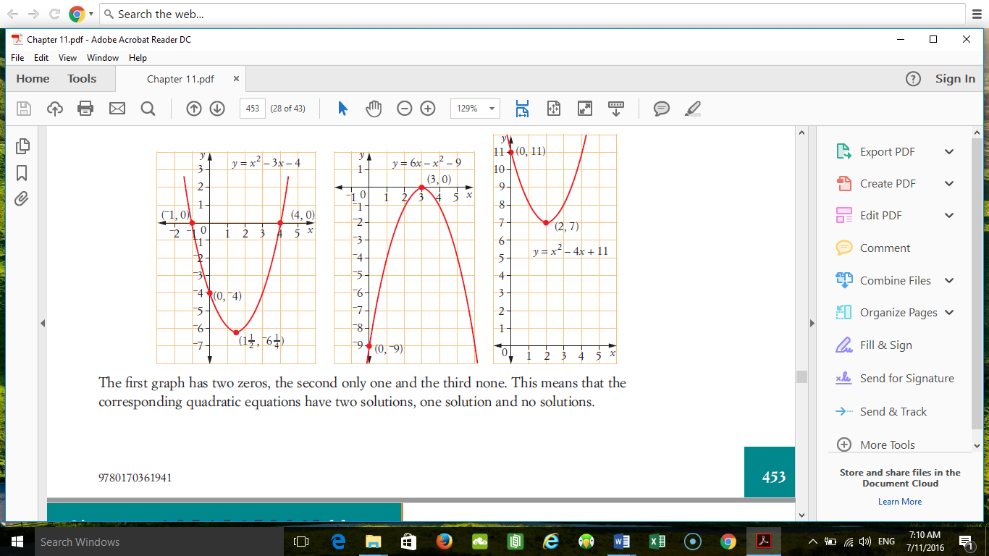 b.  c.

Line | Equation | Max/Min | Turning Point | Y intercept | Axis of Symmetry
a | y = x² - 4x + 11
b | y = 6x – x² - 9
c | y = x² – 3x - 4

END OF TEST

